Mühazirə 3.
Embryology as part of biological development
Progenesis
Comparative analysis of spermatogenesis and oogenesis
Human gametes
Fertilization
Zygote
Morulation
Blastulation, blastocyst formation at human
Gastrulation
Implantation
Axial organs of embryo
The differentiation of germ layers and axial organs of embryo
Human embryo in 2 -4 weeks

From a single cell to a baby in 9 months—a developmental process that represents an amazing integration of increasingly complex phenomena. The study of these phenomena is called embryology, and the field includes investigations of the molecular, cellular, and structural factors contributing to the formation of an organism. These studies are important because they provide knowledge essential for creating health care strategies for better reproductive outcomes. Thus, our increasingly better understanding of embryology has resulted in new techniques for prenatal diagnoses and treatments; therapeutic procedures to circumvent problems with infertility; and mechanisms to prevent birth defects, the leading cause of infant mortality. These improvements in prenatal and reproductive health care are significant not only for their contributions to improved birth outcomes but also for their long-term effects postnatally. The process of progressing from a single cell through the period of establishing organ primordia (the first 8 weeks of human development) is called the period of embryogenesis (sometimes called the period of organogenesis); the period from that point on until birth is called the fetal period, a time when differentiation continues while the fetus grows and gains weight. Scientific approaches to study embryology have progressed over hundreds of years.
Development begins with fertilization, the process by which the male gamete, the sperm, and the female gamete, the oocyte, unite to give rise to a zygote. Gametes are derived from primordial germ cells (PGCs) that are formed in the epiblast during the second week, move through the primitive streak during gastrulation, and migrate to the wall of the yolk sac . During the fourth week, these cells begin to migrate from the yolk sac toward the developing gonads, where they arrive by the end of the fifth week. Mitotic divisions increase their number during their migration and also when they arrive in the gonad. In preparation for fertilization, germ cells undergo gametogenesis, which includes meiosis, to reduce the number of chromosomes and cytodifferentiation to complete their maturation.
Oogenesis. Oogenesis is the process whereby oogonia differentiate into mature oocytes. Maturation of Oocytes Begins Before Birth. Once PGCs have arrived in the gonad of a genetic female, they diнferentiate into oogonia . These cells undergo a number of mitotic divisions, and by the end of the third month, they are arranged in clusters surrounded by a layer of flat epithelial cells. Whereas all of the oogonia in one cluster are probably derived from a single cell, the flat epithelial cells, known as follicular cells, originate from surface epithelium covering the ovary.The majority of oogonia continue to divide by mitosis, but some of them arrest their cell division in prophase of meiosis I and form primary oocytes . During the next few months, oogonia increase rapidly in number, and by the fifth month of prenatal development, the total number of germ cells in the ovary reaches its maximum, estimated at 7 million. At this time, cell death begins, and many oogonia as well as primary oocytes degenerate and become atretнc. By the seventh month, the majority of oogonia have degenerated except for a few near the surface. All surviving primary oocytes have entered prophase of meiosis I, and most of them are individually surrounded by a layer of flat follicular epithelial cells . A primary oocyte, together with its surrounding flat epithelial cells, is known as a primordial follicle . Near the time of birth, all primary oocytes have started prophase of meiosis I, but instead of proceeding into metaphase, they enter the diplotene stage, a resting stage during prophase that is characterized by a lacy network of chromatin. Primary oocytes remain arrested in prophase and do not finish their first meiotic division before puberty is reached. This arrested State is produced by oocyte maturation inhibitor (OMI), a small peptide secreted by follicular cells. The total number of primary oocytes at birth is estimated to vary from 600,000 to 800,000. During childhood, most oocytes become atretic; only approximately 40,000 are present by the beginning of puberty, and fewer than 500 will be ovulated. Some oocytes that reach maturity late in life have been dormant in the diplotene stage of the first meiotic division for 40 years or more before ovulation. Whether the diplotene stage is the most suitable phase to protect the oocyte against environmental influences is unknown. The fact that the risk of having children with chromosomal abnormalities increases with maternal age indicates that primary oocytes are vulnerable to damage as they age. At puberty, a pool of growing follicles is established and continuously maintained from the supply of primordial follicles. Each month, 15 to 20 follicles selected from this pool begin to mature. Some of these die, whereas others begin to accumulate fluid in a space called the antrum, thereby entering the antral or vesicular stage . Fluid continues to accumulate such that, immediately prior to ovulation, follicles are quite swollen and are called mature vesicular follicles or graafian follicles . The antral stage is the longest, whereas the mature vesicular stage encompasses approximately 37 hours prior to ovulation. As primordial follicles begin to grow, surrounding foflicular cells change from flat to cuboidal and proliferate to produce a stratified epithelium of granulosa cells, and the unit is called a primary follicle. Granulosa cells rest on a basement membrane separating them from surrounding ovarian connective tissue (stromal cells) that form the theca folliculi. Also, granulosa cells and the oocyte secrete a layer of glycoproteins on the surface of the oocyte, forming the zona pellucida . As follicles continue to grow, cells of the theca folliculi organize into an inner layer of secretory cells, the theca interna, and an outer fibrous capsule, the theca externa. Also, small, finger-like processes of the follicular cells extend across the zona pellucida and interdigitate with microvilli of the plasma membrane of the oocyte. These processes are important for transport of materials from follicular cells to the oocyte. As development continues, fluid-filled spaces appear between granulosa cells. Coalescence of these spaces forms the antrum, and the follicle is termed a vesicular or an antral follicle. Initially, the antrum is crescent-shaped, but with time, it enlarges . Granulosa cells surrounding the oocyte remain intact and form the cumulus oophorus. At maturity, the mature vesicular (graafian) follicle may be 25 mm or more in diameter. It is surrounded by the theca interna, which is composed of cells having characteristics of steroid secretion, rich in blood vessels,and the theca externa, which gradually merges with the ovarian connective tissue (Fig. 3.1). With each ovarian cycle, a number of follicles begin to develop, but usually, only one reaches full maturity. The others degenerate and become atretic. When the secondary follicle is mature, a surge in luteinizing hormone (LH) induces the preovulatory growth phase. Meiosis I is completed, resulting in formation of two daughter cells of unequal size, each with 23 double-structured chromosomes . One cell, the secondary oocyte, receives most of the cytoplasm; the other, the first polar body, receives practically none. The first polar body lies between the zona pellucida and the cell membrane of the secondary oocyte in the perivitelline space. The cell then enters meiosis II but arrests in metaphase approximately 3 hours before ovulation. Meiosis II is completed only if the oocyte is fertilized; otherwise, the cell degenerates approximately 24 hours after ovulation. The first polar body may undergo a second division.

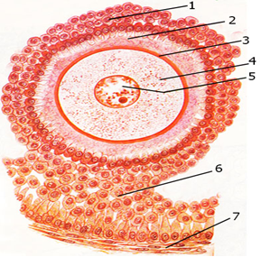
Figure 3.1.

Spermatogenesis, which begins at puberty, includes all of the events by which spermatogonia are transformed into spermatozoa. At birth, germ cells in the male infant can be recognized in the sex cords of the testis as large, pale cells surrounded by supporting cells. Supporting cells, which are derived from the surface epithelium of the testis in the same manner as follicular cells, become sustentacular cells, or Sertoli cells . Shortly before puberty, the sex cords acquire a lumen and become the seminiferous tubules. At about the same time, PGCs give rise to spermatogonial stem cells. At regular intervals, cells emerge from this stem cell population to form type A spermatogonia, and their production marks the initiation of spermatogenesis. Type A cells undergo a limited number of mitotic divisions to form clones of cells. The last cell division produces type B spermatogonia, which then divide to form primary spermatocytes . Primary spermatocytes then enter a prolonged prophase (22 days) followed by rapid completion of meiosis I and formation of secondary spermatocytes. During the second meiotic divisiуn, these cells immediately begin to form haploid spermatids.Throughout this series of events, from the time type A cells leave the stem cell population to formation of spermatids, cytokinesis is incomplete, so that successive cell generations are joined by cytoplasmic bridges. Thus, the progeny of a single type A spermatogonium form a clone of germ cells that maintain contact throughout diнferentiation . Furthermore, spermatogonia and spermatids remain embedded in deep recesses of Sertoli cells throughout their development . In this manner, Sertoli cells support and protect the germ cells, participate in their nutrition, and assist in the release of mature spermatozoa. Spermatogenesis is regulated by LH production by the pituitary gland. LH binds to receptors on Leydig cells and stimulates testosterone production, which in turn binds to Sertoh cells to promote spermatogenesis. Follicle-stimulating hormone (FSH) is also essential because its binding to Sertoli cells stimulates testicular fluid production and synthesis of intracellular androgen receptor proteins. Spermiogenesis. The series of changes resulting in the transformation of spermatids into spermatozoa is spermiogenesis. These changes include (1) formation of the acrosome (Fig. 3.2.), which covers half of the nuclear surface and contains enzymes to assist in penetration of the egg and its surrounding layers during fertilization (2) condensation of the nucleus; (3) formation of neck, middle piece, and tail (Fig 3.3.); and (4) shedding of most of the cytoplasm as residual bodies that are phagocytized by Sertoli cells. In humans, the time required for a spermatogonium to develop into a mature spermatozoon is approximately 74 days, and approximately 300 million sperm cells are produced daily. When fully formed, spermatozoa enter the lumen of seminiferous tubules. From there, they are pushed toward the epididymis by contractile elements in the wall of the seminiferous tubules. Although initially only shghtly motile, spermatozoa obtain full motility in the epididymis.
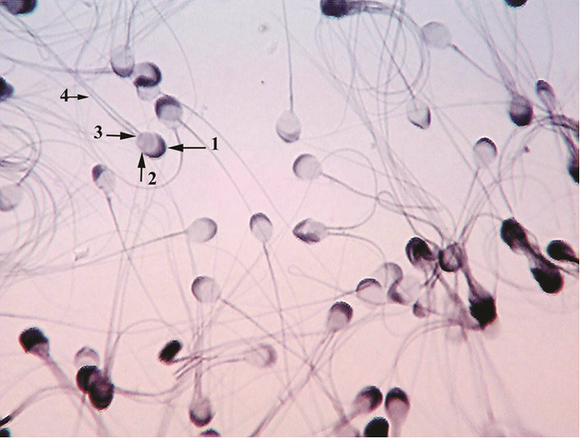

Figure 3.2.

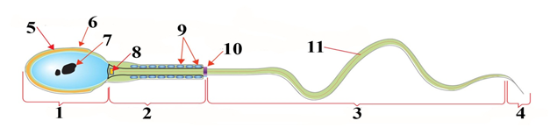

Figure 3.3.
Fertilization, the process by which male and female gametes fuse, occurs in the ampullary region of the uterine tube. This is the widest part of the tube and is close to the ovary . Spermatozoa may remain viable in the female reproductive tract for several days. Only 1% of sperm deposited in the vagina enter the cervix, where they may survive for many hours. Movement of sperm from the cervix to the uterine tube occurs by muscular contractions of the uterus and uterine tube and very little by their own propulsion. The trip from cervix to oviduct can occur as rapidly as 30 minutes or as slow as 6 days. After reaching the isthmus, sperm become less motile and cease their migration. At ovulation, sperm again become motile, perhaps because of chemoattractants produced by cumulus cells surrounding the egg, and swim to the ampulla, where fertilization usually occurs. Spermatozoa are not able to fertilize the oocyte immediately upon arrival in the female genital tract but must undergo (1) capacitation and (2) the acrosome reaction to acquire this capability. Capacitatнon is a period of conditioning in the female reproductive tract that in the human lasts approximately 7 hours. Thus, speeding to the ampulla is not an advantage because capacitation has not yet occurred and such sperm are not capable of fertilizing the egg. Much of this conditioning during capacitation occurs in the uterine tube and involves epithelial interactions between the sperm and the mucosal surface of the tube. During this time, a glycoprotein coat and seminal plasma proteins are removed from the plasma membrane that overlies the acrosomal region of the spermatozoa. Only capacitated sperm can pass through the corona cells and undergo the acrosome reaction.The acrosome reaction, which occurs after binding to the zona pellucida, is induced by zona proteins. This reaction culminates in the release of enzymes needed to penetrate the zona pellucida, including acrosin- and trypsin-like substances (Fig. 3.4). The phases of fertilization include the following:
■ Phase 1, penetration of the corona radiata
■ Phase 2, penetration of the zona pellucida
■ Phase 3, fusiуn of the oocyte and sperm cell membranes

Phase 1: Penetratнon of the Corona Radiata. Of the 200 to 300 million spermatozoa normally depositad in the female genital tract, only 300 to 500 reach the site of fertilization. Only one of these fertilizes the egg. It is thought that the others aid the fertilizing sperm in penetrating the barriers protecting the female gamete. Capacitated sperm pass freely through corona cells.
Phase 2: Penetratнon of the Zona Pellucida. The zona is a glycoprotein shell surrounding the egg that facilitates and maintains sperm binding and induces the acrosome reaction. Both binding and the acrosome reaction are mediated by the ligand ZP3, a zona protein. Release of acrosomal enzymes (acrosin) allows sperm to penetrate the zona, thereby coming in contact with the plasma membrane of the oocyte . Permeability of the zona pellucida changes when the head of the sperm comes in contact with the oocyte surface. This contact results in release of lysosomal enzymes from cortical granules lining the plasma membrane of the oocyte. In turn, these enzymes alter properties of the zona pellucida (zona reaction) to prevent sperm penetration and inactivate species-specific receptor sites for spermatozoa on the zona surface. Other spermatozoa have been found embedded in the zona pellucida, but only one seems to be able to penetrate the oocyte (Fig. 3.4).
Phase 3: Fusion of the Oocyte and Sperm Cell Membranes. The initial adhesion of sperm to the oocyte is mediated in part by the interaction of integrins on the oocyte and their ligands, disintegrins, on sperm. After adhesion, the plasma membranes of the sperm and egg fuse. Because the plasma membrane covering the acrosomal head cap disappears during the acrosome reaction, actual fusion is accomplished between the oocyte membrane and the membrane that covers the posterior region of the sperm head. In the human, both the head and the tail of the spermatozoon enter the cytoplasm of the oocyte, but the plasma membrane is left behind on the oocyte surface. As soon as the spermatozoon has entered the oocyte, the egg responds in three ways:
1. Cortical and zona reactions. As a result of the release of cortical oocyte granules, which contain lysosomal enzymes, (1) the oocyte membrane becomes impenetrable to other spermatozoa, and (2) the zona pellucida alters its structure and composition to prevent sperm binding and penetration. These reactions prevent polyspermy (penetration of more than one spermatozoon into the oocyte).
2. Resumption of the second meiotic division. The oocyte finishes its second meiotic divisiуn immediately after entry of the spermatozoon. One of the daughter cells, which receives hardly any cytoplasm, is known as the second polar body; the other daughter cell is the definitive oocyte. Its chromosomes (22 plus X) arrange themselves in a vesicular nucleus known as the female pronucleus.
3. Metabolic activation of the egg. The activating factor is probably carried by the spermatozoon. Activation encompasses the initial cellular and molecular events associated with early embryogenesis.
The spermatozoon, meanwhile, moves forward until it lies ciуse to the female pronucleus. Its nucleus becomes swollen and forms the male pronucleus, the tail detaches and degenerates. Morphologically, the male and female pronuclei are indistinguishable, and eventually, they come into ciуse contact and lose their nuclear envelopes. During growth of male and female pronuclei (both haploid), each pronucleus must replнcate its DNA. If it does not, each cell of the two-cell zygote has only half of the normal amount of DNA. Immediately after DNA synthesis, chromosomes organize on the spindle in preparation for a normal mitotic divisiуn. The 23 maternal and 23 paternal (double) chromosomes split longitudinally at the centromere, and sister chromatids move to opposite poles, providing each cell of the zygote with the normal diploid number of chromosomes and DNA. As sister chromatids move to opposite poles, a deep furrow appears on the surface of the cell, gradually dividing the cytoplasm into two parts (Fig.3.5 A).

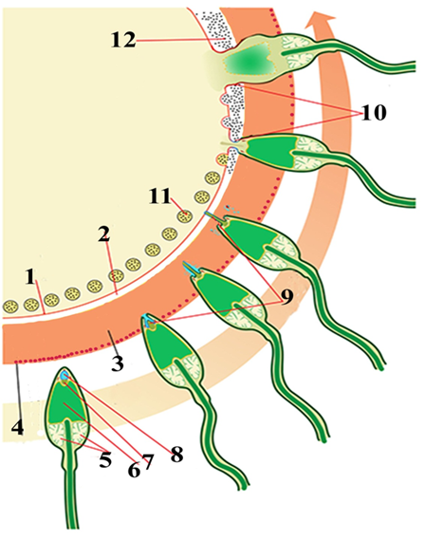
Figure 3.4.

Once the zygote has reached the two-cell stage, it undergoes a series of mitotic divisions, increasing the numbers of cells. These cells, which become smaller with each cleavage division, are known as blastomeres. Until the eight-cell stage, they form a loosely arranged clump (Fig. 3.5B). After the third cleavage, however, blastomeres maximize their contact with each other, forming a compact ball of cells held together by tight junctions (Fig. 3.5C). This process, compaction, segregates inner cells, which communicate extensively by gap junctions, from outer cells. Approximately 3 days after fertilization, cells of the compacted embryo divide again to form a 16-cell morula (mulberry). Inner cells of the morula constitute the inner cell mass, and surrounding cells compose the outer cell mass. The inner cell mass gives rise to tissues of the embryo proper, and the outer cell mass forms the trophoblast, which later contributes to the placenta (Fig. 3.5Ç).
BLASTOCYST FORMATION. About the time the morula enters the uterine cavity, fluid begins to penetrate through the zona pellucida into the intercellular spaces of the inner cell mass. Gradually, the intercellular spaces become confluent, and finally, a single cavity, the blastocele, forms . At this time, the embryo is a blastocyst. Cells of the inner cell mass, now called the embryoblast, are at one pole, and those of the outer cell mass, or trophoblast, flatten and form the epithelial wall of the blastocyst (Fig. 3.5 D).
Figure 3.5.

The zona pellucida has disappeared, allowing implantation to begin. In the human, trophoblastic cells over the embryoblast pole begin to penetrate between the epithelial cells of the uterine mucosa on about the sixth day. New studies suggest that L-selectin on trophoblast cells and its carbohydrate receptors on the uterine epithelium mediate initial attachment of the blastocyst to the uterus. Selectins are carbohydrate-binding proteins involved in interactions between leukocytes and endothelial cells that allow leukocyte “capture” from flowing blood. A similar mechanism is now proposed for “capture” of the blastocyst from the uterine cavity by the uterine epithelium. Following capture by selectins, further attachment and invasion by the trophoblast involve integrins, expressed by the trophoblast and the extracellular matrix molecules laminin and fibronectin. Integrin receptors for laminin promote attachment, whereas those for fibronectin stimulate migration. These molecules also interact along signal transduction pathways to regulate trophoblast differentiation, so that implantation is the result of mutual trophoblastic and endometrial action. Henee, by the end of the first week of development, the human zygote has passed through the morula and blastocyst stages and has begun implantation in the uterine mucosa (Fig. 3.6 E) Impiantation occurs at the end of the first week. Trophoblast cells invade the epithelium and underlying endometrial stroma with thehelp of proteolytic enzymes. Impiantation may also occur outside the uterus, such as in the rectouterine pouch, on the mesentery, in the uterine tube, or in the ovary (ectopic pregnancies).
Figure 3.6
At the eighth day of development, the blastocyst is partially embedded in the endometrial stroma. In the area over the embryoblast, the trophoblast has differentiated into two layers: (1) an inner layer of mononucleated cells, the cytotrophoblast, and (2) an outer multinucleated zone without distinct cell boundaries, the syncytiotrophoblast (Figs. 3.6 F). Mitotic figures are found in the cytotrophoblast but not in the syncytiotrophoblast. Thus, cells in the cytotrophoblast divide and migrate into the syncytiotrophoblast, where they fuse and lose their individual cell membranes.Cells of the inner cell mass or embryoblast also differentiate into two layers: (1) a layer of small cuboidal cells adjacent to the blastocyst cavity, known as the hypoblast layer, and (2) a layer of high columnar cells adjacent to the amniotic cavity, the epiblast layer. Together, the layers form a flat disc. The blastocyst is more deeply embedded in the endometrium, and the penetration defect in the surface epithehum is closed by a fibrin coagulum. The trophoblast shows considerable progress in development, particularly at the embryonic pole, where vacuoles appear in the syncytium. When these vacuoles fiise, they form large lacunae, and this phase of trophoblast development is thus known as the lacunar stage (Figs. 3.6G).

Figure 3.7.
At the same time, a small cavity appears within the epiblast. This cavity enlarges to become the amniotic cavity. Epiblast cells adjacent to the cytotrophoblast are called amnioblasts; together with the rest of the epiblast, they line the amniotic cavity.The endometrial stroma adjacent to the implantation site is edematous and highly vascular. The large, tortuous glands secrete abundant glycogen and mucus.
In the meantime, a new population of cells appears between the inner surface of the cytotrophoblast and the outer surface of the exocoelomic cavity. These cells, derived from yolk sac cells, form a fine, loose connective tissue, the extraembryonic mesoderm, which eventually filis all of the space between the trophoblast externally and the amnion and exocoelomic membrane internally (Figs. 3.7H). Soon, large cavities develop in the extraembryonic mesoderm, and when these become confluent, they form a new space known as the extraembryonic cavity, or chorionic cavity. This space surrounds the primitive yolk sac and amniotic cavity, except where the germ disc is connected to the trophoblast by the connecting stalk (Fig. 3.7X). The extraembryonic mesoderm lining the cytotrophoblast and amnion is called the extraembryonic somatic mesoderm; the lining covering the yolk sac is known as the extraembryonic splanchnic mesoderm . Growth of the bilaminar disc is relatively slow compared with that of the trophoblast; consequently, the disc remains very small (0.1 to 0.2 mm). Cells of the endometrium, meanwhile, become polyhedral and loaded with glycogen and lipids; intercellular spaces are filled with extravasate, and the tissue is edematous. These changes, known as the decidua reaction, at first are confined to the area immediately surrounding the implantation site but soon occur throughout the endometrium.
The trophoblast is characterized by villous structures. Cells of the cytotrophoblast proliferate locally and penetrate into the syncytiotrophoblast, forming cellular columns surrounded by syncytium. Cellular columns with the syncytial covering are known as primary villi (Fid.3.7X).
In the meantime, the hypoblast produces additional cells that migrate along the inside of the exocoelomic membrane . These cells proliferate and gradually form a new cavity within the exocoelomic cavity. This new cavity is known as the secondary yolk sac or definitive yolk sac (Figs. 3.7H). This yolk sac is much smaller than the original exocoelomic cavity, or primitive yolk sac. During its formation, large portions of the exocoelomic cavity are pinched off. These portions are represented by exocoelomic cysts, which are often found in the extraembryonic coelom or chorionic cavity . Meanwhile, the extraembryonic coelom expands and forms a large cavity, the chorionic cavity. The extraembryonic mesoderm lining the inside of the cytotrophoblast is then known as the chorionic plate. The only place where extraembryonic mesoderm traverses the chorionic cavity is in the connecting stalk. With development of blood vessels, the stalk becomes the umbilical cord (Fig. 3.7X).
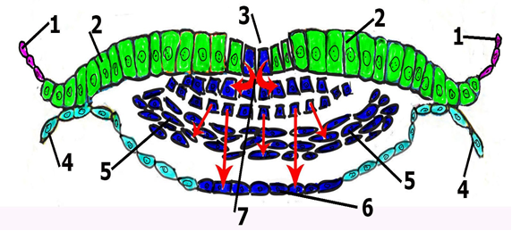
Figure 3.8
The most characteristic event occurring during the third week is gastrulation, which begins with the appearance of the primitive streak, which has at its cephalic end the primitive node. In the region of the node and streak, epiblast cells move inward (invaginate) to form new
cell layers, endoderm and mesoderm. Cells that do not migrate through the streak but remain in the epiblast form ectoderm. Henee, epiblast gives rise to all three germ layers in the embryo, ectoderm, mesoderm, and endoderm, and these layers form all of the tissues and organs (Figs. 3.8).
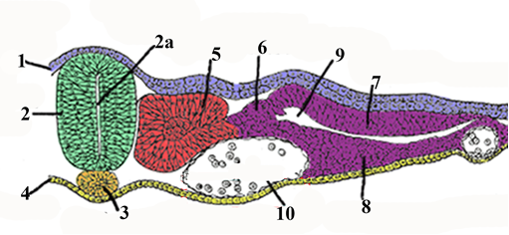
Figure 3.9

The embryonic period, or period of organogenesis, occurs from the third to the eighth weeks of development and is the time when each of the three germ layers, ectoderm, mesoderm, and endoderm, gives rise to a number of specific tissues and organs. By the end of the embryonic period, the main organ systems have been established, rendering the major features of the external body form recognizable by the end of the second month. Neurulation is the process whereby the neural plate forms the neural tube. One of the key events in this process is lengthening of the neural plate and body axis by the phenomenon of convergent extension, whereby there is a lateral to medial movement of cells in the plaсe of the ectoderm and mesoderm. The process is regulated by signaling through the planar cell polarity pathway and is essential for neural tube development. As the neural plate lengthens, its lateral edges elevate to form neural folds, and the depressed midregion forms the neural groove .Gradually, the neural folds approach each other in the midline, where they fuse .Fusion begins in the cervical region (fifth somite) and proceeds cranially and caudally. As a result, the neural tube is formed. Until fusion is complete, the cephalic and caudal ends of the neural tube communicate with the amniotic cavity by way of the anterior (cranial) and posterior (caudal) neuropores. respectively .Closure of the cranial neuropore occurs at approximately day 25 (18- to 20-somite stage), whereas the posterior neuropore closes at day 28 (25-somite stage) . Neurulation is then complete,and the central nervous system is represented by a closed tubular structure with a narrow caudal portion, the spinal cord, and a much broader cephalic portion characterized by a number of dilations, the brain vesicles (Fig.3.9). By the time the neural tube is closed, two bilateral ectodermal thickenнngs, the otic placodes and the lens placodes, become visible in the cephalic regiуn of the embryo . During further development, the otic placodes invaginate and form the otic vesicles, which will develop inte structures needed for hearing and maintenance of equilibrium . At approximately the same time, the lens placodes appear. These placodes also invaginate and, during the fifth week, form the lenses of the eyes . In general terms, the ectodermal germ layer gives rise to organs and structures that maintain contact with the outside world:
■ The central nervous system
■ The peripheral nervous system
■ The sensory epithelium of the ear, nose, and eye
■ The epidermis, including the hair and nails
■ The subcutaneous glands
■ The mammary glands
■ The pituitary gland
■ Enamel of the teeth
Initially, cells of the mesodermal germ layer form athin sheet of loosely woven tissue on each side of the midline. By approximately the 17th day, however, cells close to the midline proliferate and form a thickened plate of tissue known as paraxial mesoderm (Fig. 3.9). More laterally, the mesoderm layer remains thin and is known as the lateral plate. With the appearance and coalescence of intercellular cavities in the lateral plate, this tissue is divided into two layers:
■ A layer continuous with mesoderm covering the amnion, known as the somatic or parietal mesoderm layer
■ A layer continuous with mesoderm covering the yolk sac, known as the splanchnic or
visceral mesoderm layer
Together, these layers line a newly formed cavity, the intraembryonic cavity, which is continuous with the extraembryonic cavity on each side of the embryo. Intermediate mesoderm connects paraxial and lateral plate mesoderm. By the beginning of the third week, paraxial mesoderm begins to be organized into segments. These segments, known as somitomeres, first appear in the cephalic regiуn of the embryo, and their formation proceeds cephalocaudally. Each somitomere consists of mesodermal cells arranged in concentric whorls around the center of the unit. In the head regiуn, somitomeres form in association with segmentation of the neural pнate into neuromeres and contribute to mesenchyme in the head. From the occipital region caudally, somitomeres further organize into somites. The first pair of somites arises in the occipital region of the embryo at approximately the 20th day of development. From here, new somites appear in craniocaudal sequence at a rate of approximately three pairs per day until, at the end of the fifth week, 42 to 44 pairs are present. There are 4 occipital, 8 cervical, 12 thoracic, 5 lumbar, 5 sacral, and 8 to 10 coccygeal pairs. The first occipital and the last five to seven coccygeal somites later disappear, while the remaining somites form the axial skeleton . Because somites appear with a specified periodicity, the age of an embryo can be accurately determined during this early time period by counting somites (Figs. 3.10). By the beginning of the fourth week, cells in the ventral and medial walls of the somite lose their epithelial characteristics, become mesenchymal (fibroblast-like) again, and shift their position to surround the neural tube and notochord. Collectively, these cells form the sclerotome that will differentiate into the vertebrae and ribs. Cells at the dorsomedial and ventrolateral edges of the upper regiуn of the somite form precursors for muscle cells, whereas cells between these two groups form the dermatome. Cells from both muscle precursor groups become mesenchymal again and migrate beneath the dermatome to create the dermomyotome . In addition, cells from the ventrolateral edge migrate into the parietal layer of lateral pнate mesoderm to form most of the musculature for the body wall (external and internal oblique and transversus abdominis muscles) and most of the limb muscles . Cells in the dermomyotome ultimately form dermis for the skin of the back and muscles for the back, body wall (intercostal muscles), and some limb muscles . Each myotome and dermatome retains its innervation from its segment of origin, no matter where the cells migrate. Hence, each somite forms its own sclerotome (the tendon cartilage and bone component), its own myotome (providing the segmental muscle component), and its own dermatome, which forms the dermis of the back. Each myotome and dermatome also has its own segmental nerve component.
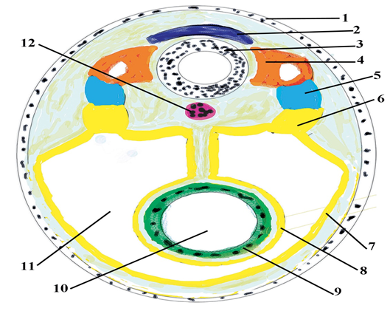
Figure 3.10
Intermediate Mesoderm. Intermediate mesoderm, which temporarily connects paraxial mesoderm with the lateral plate (Fig. 3.9), differentiates into urogenital structures. In cervical and upper thoracic regions, it forms segmental cell clusters (future nephrotomes), whereas more caudally, it forms an unsegmented mass of tissue, the nephrogenнc cord. Excretory units of the urinary system and the gonads develop from this partly segmented, parьy unsegmented intermediate mesoderm. Lateral Plate Mesoderm. Lateral plate mesoderm splits into parietal (somatic) and visceral (splanchnic) layers, which line the intraembryonic cavity and surround the organs, respectively . Mesoderm from the parietal layer, together with overlying ectoderm, forms the lateral body wall folds (Fig. 3.10). These folds, together with the head (cephalic) and tail (caudal) folds, close the ventral body wall. The parietal layer of lateral plate mesoderm then forms the dermis of the skin in the body wall and limbs, the bones and connective tissue of the limbs, and the sternum. In addition, sclerotome and muscle precursor cells that migrate into the parietal layer of lateral pнate mesoderm form the costal cartilages, limb muscles, and most of the body wall muscles . The visceral layer of lateral plate mesoderm, together with embryonic endoderm, forms the wall of the gut tube (Fig. 3.10). Mesoderm cells of the parietal layer surrounding the intraembryonic cavity form thin membranes, the mesothelial membranes, or serous membranes, which will line the peritoneal, pleural, and pericardial cavities and secrete serous fluid. Mesoderm cells of the visceral layer form a thin serous membrane around each organ .
The gastrointestinal tract is the main organ system derived from the endodermal germ layer. This germ layer covers the ventral surface of the embryo and forms the roof of the yolk sac . With development and growth of the brain vesicles, however, the embryonic disc begins to bulge into the amniotic cavity. Lengthening of the neural tube now causes the embryo to curve into the fetal position as the head and tail regions (folds) move ventrally. Simultaneously, two lateral body wall folds form and also move ventrally to close the ventral body wall . As the head and tail and two lateral folds move ventrally, they pull the amnion down with them, such that the embryo lies within the amniotic cavity. The ventral body wall closes completely except for the umbilical region where the connecting stalk and yolk sac duct remain attached. Failure of the lateral body folds to close the body wall results in ventral body wall defects . As a result of cephalocaudal growth and closure of the lateral body wall folds, a continuously larger portion of the endodermal germ layer is incorporated into the body of the embryo to form the gut tube. The tube is divided into three regions: the foregut, midgut, and hindgut . The midgut communicates with the yolk sac by way of a broad stalk, the vitelline (yolk sac) duct . This duct is wide initially, but with further growth of the embryo, it becomes narrow and much longer . At its cephalic end, the foregut is temporarily bounded by an ectodermal-endodermal membrane called the oropharyngeal membrane. This membrane separates the stomodeum, the primitive oral cavity derived from ectoderm, from the pharynx, a part of the foregut derived from endoderm. In the fourth week, the oropharyngeal membrane ruptures, establishing an open connection between the oral cavity and the primitive gut . The hindgut also terminales temporarily at an ectodermal-endodermal membrane, the cloacal membrane. This membrane separates the upper part of the anal canal, derived from endoderm, from the lower part, called the proctodeum, which is formed by an invaginating pit lined by ectoderm. The membrane breaks down in the seventh week to create the opening for the anus. Another important result of cephalocaudal growth and lateral folding is partial incorporation of the allantois into the body of the embryo, where it forms the cloaca .

